Main Menus:

Our Company menu Items:

This is for Features

My Page Menu:

Employee Menu:



Contacts Menu:

Clients Menu:



Sub Contractor Menu:



Manual Menu:



Follow Up Menu:

In This when we click Note and SJA Forms menu, it only shows the Note details.

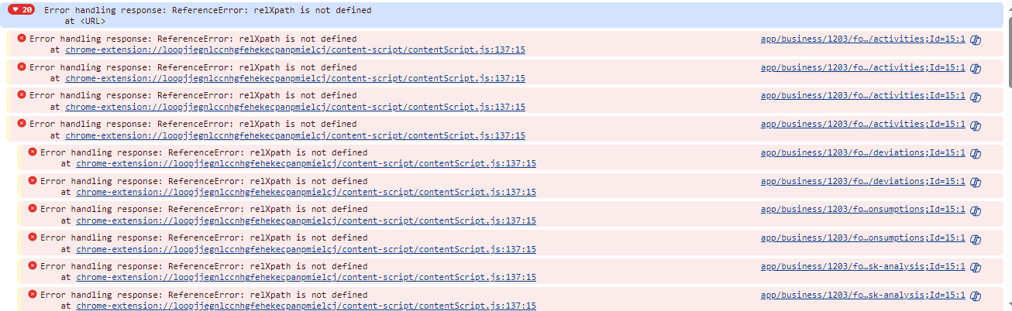

Projects Menu:



FDV Registry Menu:

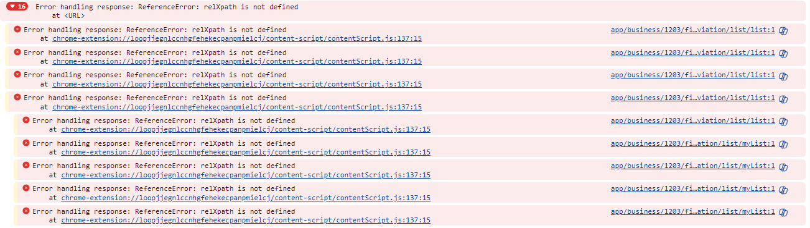

Internal Control Menu:

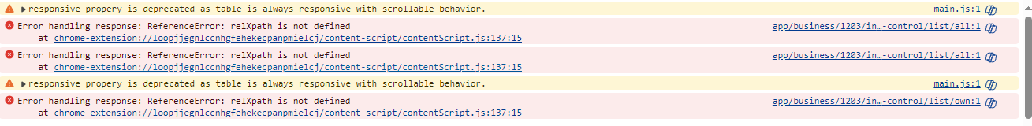

Other System Registry Menu:

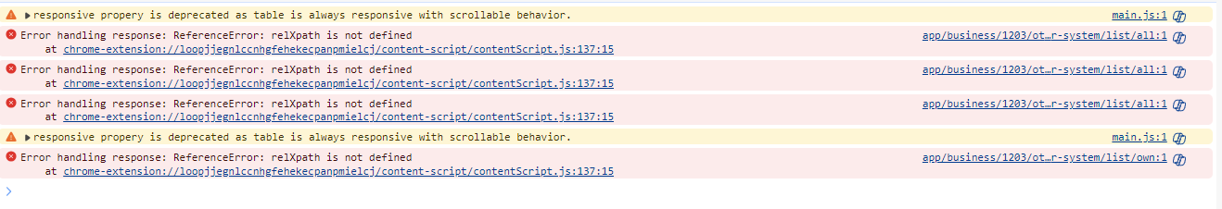

Quality System Registry Menu:

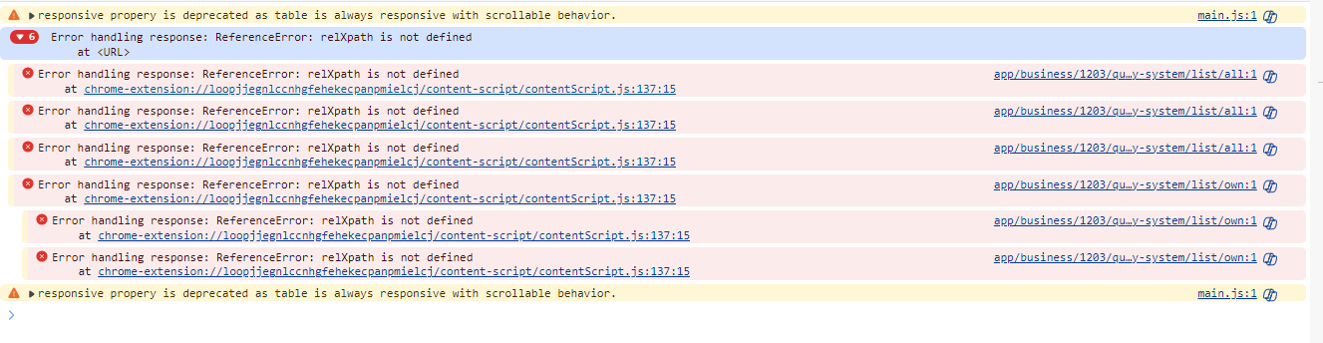

Food Safety Zone Menu:

Control Object Menu:

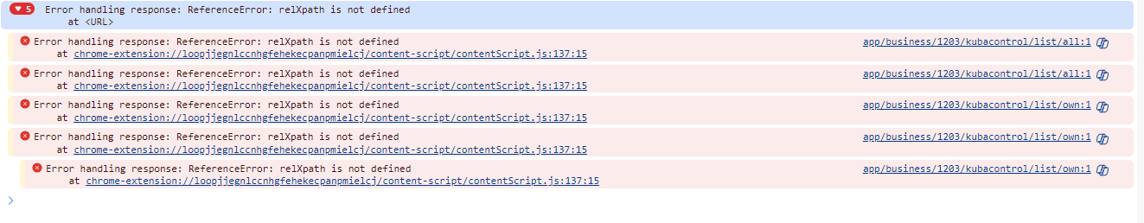

Vehicle List Menu:

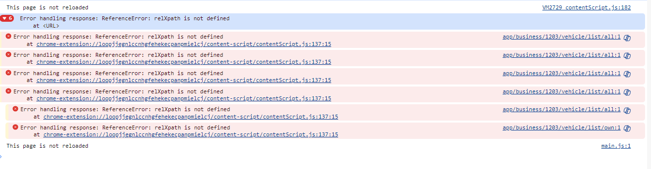

Our Supplier Menu:

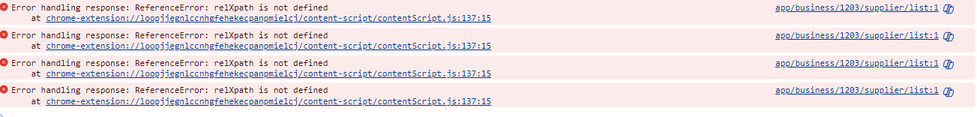

Archive Menu:

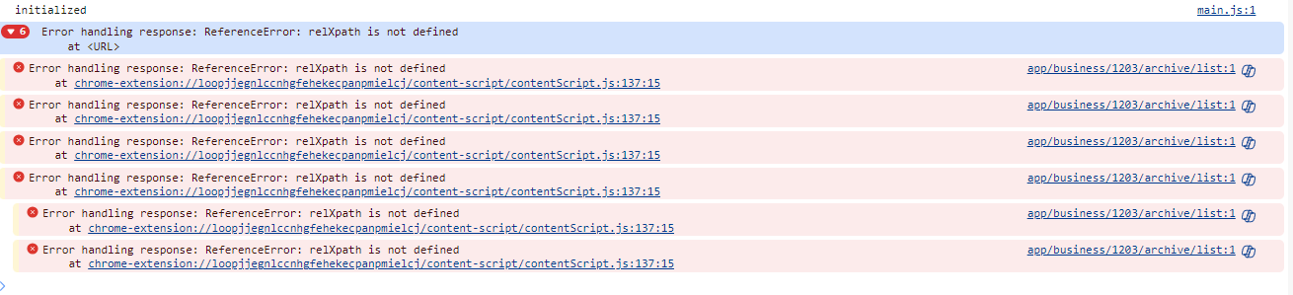

Internal News Menu:

Flexi Menu:



